Module Seven: Scenario Analysis
Operational Risk Management: A Complete Guide to a Successful Operational Risk Framework
Chapter 11
11/22

Learning Objectives
- Explain ways that data analysis might be used to support the scenario analysis modeling of rare events

Role of Scenario Analysis
- explores the rare but plausible losses that could arise as a result of operational risk
- evaluates a firm’s exposure to high-severity events
- focuses on the “fat tail” events, or rare catastrophic events
- provides valuable insight into the major risks faced
- provides the opportunity for an engaging dialogue with the business lines
- used to derive reasoned assessments of plausible severe losses
- assessments are then used to explore “what-if” cases that may be beyond the current experience of the firm
- external data plays a key role in scenario analysis, as it provides insight into what has already occurred in other firms

Approaches
- workshops, interviews, hybrids, etc
- can cover each risk category in each business or only a few scenarios at the corporate level
- can have standard scenarios for every business line to consider or have each business line develop their own

Elements of an Established Scenario Analysis Framework
- A clearly defined and repeatable process
  - develop written procedures and standards that will be applied every time a scenario analysis activity is run
  - auditors and regulators will pore over these documents and will carefully compare them to the process that actually occurred
  - process should provide the maximum benefit and least disruption to the businesses that are involved
  - corporate operational risk function will likely by responsible for preparation, facilitation, and postscenario documentation and validation
- Good quality background preparation of the participants in the scenario generation process
  - Interviews
  - Internal Loss Data
    - provides a floor for losses
    - should not be shared directly with those participating in the discussion
  - External Loss Data
    - Information on these events can be helpful in developing a what-if scenario for the firm
  - RCSA Results
    - Scenario analysis should also feed back into the RCSA program, further enriching the risks library that is constantly evolving in the operational risk framework
  - Compliance and Audit Findings
    - helpful in challenging claims that a control or a set of controls is working well
  - Key Metrics and Analysis
    - alleviates the difficulties in estimation and seems to be well received by regulators so far
  - Straw Man Scenario List
    - participants in scenario analysis activities are better equipped to consider scenarios if they are provided with appropriate background resources
- Qualified and experienced facilitators with consistency in the facilitation process
  - there needs to be a neutral facilitator who not only knows the process completely but is also proficient at managing the conversations to ensure that no one person, or small group, is dominating the discussion and that all ideas are heard
- The appropriate representatives of the business, subject matter experts and the corporate operational risk management function as participants involved in the process
  - written procedures for scenario analysis should include a list of the required quorum
- A structured process for the selection of data used in developing scenario estimates
  - data include all background preparation data and the estimates that are solicited from the participants during the workshop
  - common determinants:
    - worst case losses or average
    - likelihood of specfic scenarios or general categories
- High quality documentation which provides clear reasoning and evidence supporting the scenario output
  - there is often a second neutral participant, perhaps from the corporate operational risk function, whose sole role is to document the proceedings
  - needs to be a well-documented summary at the end of the process that outlines the thought processes, the data and evidence that was weighed and considered and the reason that consensus has been reached on certain conclusions such as severity and frequency
- A robust independent challenge process and oversight by the corporate operational risk management function to ensure the appropriateness of scenario estimates
  - corporate operational risk function can meet this challenge and oversight requirement by being actively involved in all preparation work, in the scenario analysis activities, and in the review of the documentation
  - helpful to establish a formal challenge and review process after the activity
- A process that is responsive to changes in both the internal and external environment
  - scenario analysis activity should capture the current state of the business and control environments
  - should be designed to ensure that any changes in those environments will trigger a new activity as appropriate
  - many firms will require them to be updated once a year even if no trigger has arisen
- Mechanisms for mitigating biases inherent in scenario processes. Such biases include anchoring, availability and motivational biases
  - two classes of bias
    - judgmental
      - occurs during the estimation process as the experts are swayed by the background data and the form of the questions
      - examples
        - availability
        - anchoring
    - motivational
      - occurs where the estimates of the participants are influenced not by the data presented, but by the personal interest of the participants themselves
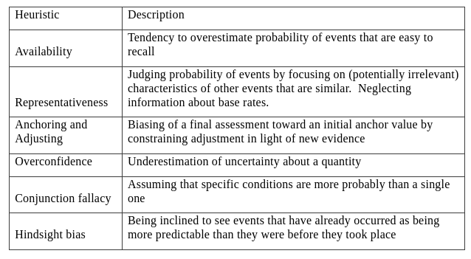
Scenario Analysis Output
- may produce an average loss estimate, a worst-case loss estimate and frequency estimates for each of these values
  - some produce just the worst-case estimate and a single frequency estimate
  - others produce a range of loss estimates, with frequency estimates for each loss
  - others produce the latter range plus a maximum loss estimate
- can be analyzed by category or individual scenario
- output drives how the scenario analysis information is then used for risk management or for capital calculation purposes, and the model that is applied to calculating capital for the firm

